JPPS 2008; 5(1): 27-30 AUDIT

AN AUDIT ON MONITORING OF METABOLIC SYNDROME IN A COMMUNITY MENTAL HEALTH TEAM IN UK

Roohi Afshan, Farida Yousaf

# ABSTRACT

**Objective:** This audit looked at the current practice of the community mental health teams in identifying patients at high risk of metabolic syndrome comparing its practice to a standard established through literature.

**Design:** Cross Sectional Study

**Place & Duration of Audit:** Audit was carried out in Dorking Community mental health team in UK in August 2006 and repeated in September 2007.

**Subjects & Methods:** Patients who were registered with the Dorking Community mental health team (CMHT ) and were receiving antipsychotic medications. Retrospective study on patients on antipsychotic medication against a standard established through literature search. In the audit in August 2006, 42 were randomly selected of 59 fulfilling the criteria in a total of 65 patients on antipsychotic while 35 of 72 patients on antipsychotics were randomly selected in the re audit in September 2007.

**Results:** Identification and documentation improved among all the parameters from family and personal history of diabetes to documentation of blood pressure, blood glucose, weight and lipids to a significant extent.

**Conclusion:** Increased awareness and education of team members had a positive impact on monitoring which should be kept simple and practical.

**Key words:** Audit, Metabolic syndrome, Mental illness

# INTRODUCTION

Metabolic Syndrome is associated with increased risk of cardiovascular morbidity and mortality and is de- fined by International Diabetic Federation (IDF) as hav- ing a central obesity and presence of two or more of the following factors: (1) Raised triglycerides, (2) raised blood pressure, (3) reduced HDL(high density lipopro- teins) or/ and (4) raised blood glucose1.

Other factors that are non modifiable such as: age above forty, male gender, Asian or Black racial origin and a family history of diabetes mellitus, further increase the risk of this syndrome.

A sedentary life style, smoking, poor dietary hab- its, reduced access to medical care, poor judgement of health status and medications (atypical antipsychotics,

**Roohi Afshan**, MBBS, MRCPsych, Specialist Registrar old age team , Spring field University Hospital, 61 Glenburnie Road. Tooting. London. SW17 7DJ. Email: [afshan.k@btinternet.com,](mailto:afshan.k@btinternet.com) **Farida Yousaf**, MBBS, FRCPsych, Consultant Psychiatrist, Surrey and Borders Partnership NHS Trust, Mole Valley Pri- mary Community Mental Health Team, Clarendon House, 28 West Street, Dorking, Surrey, RH4 1QJ

**Correspondence: Dr. Roohi Afshan**

antidepressants and mood stabilisers) contribute to the increased prevalence of metabolic syndrome and its fatal consequences2,3 in people with enduring and se- vere mental illnesses. Thus hyperglycemias, type 2 dia- betes, ischeamic heart disease and obesity are more common in patients with schizophrenia than in the gen- eral population. Reports have suggested that people with severe mental illness are up to five times more likely to have diabetes and twice as likely to die from cardio- vascular disease4.

Historically people with severe and enduring men- tal illness are less likely to access the primary care ser- vices. Their main point of contact remains the psychiat- ric services. It is, therefore, imperative that the mental health services take up this challenge proactively. Early identification of patients with high risk factors and man- aging the risk of metabolic syndrome can go a long way in improving the physical health of these patients. In the UK where there is a well-established system of almost everyone being registered with a primary care physi- cian, there is still a debate going on about whether this task should fall on the GP or the mental health ser- vices **5.**

Audit is defined as “ The systematic and critical analysis of the quality of medical care” 6. These can be

Table 1

Definition of Metabolic Syndrome1

Plus two or more of the following factors: Raised Triglycerides >/=1.7mmol/L Reduced HDLMen <1.0mmol/L

Men <1.3mmol/L

Women <1.3mmol/L Raised Blood Pressure >/=130/85 mmHg

Raised Fasting Plasma >/+6.1mmol/L Glucose

Waist circumference

>/=94 cm

>/=80 cm

Abdominal obesity Men

Women

**Defining Value**

**Risk factors**

classified as the audits of the service structure, process of care and outcomes of clinical interventions. The pro- cess of audit should follow audit cycle i.e, setting stan- dards, comparison of practice against standards, im- provement of practice and then completing the loop by re-auditing7.

We aimed to carry out an audit on monitoring of the metabolic syndrome in a community mental health team in the affluent area of Surrey where morbidity is lower than the UK national average. The audit was car- ried out with an aim of comparing the current practice with a standard and developing a workable protocol for the team to enable them to proactively identify patients with increased risk of metabolic syndrome.

# SUBJECTS AND METHODS

The standard against which the team’s perfor- mance was compared was established through litera- ture search8,9.

The minimum standard we established for the au- dit purposes was that baseline investigations as out- lined in Table 2 should be carried out whenever a new

Table 2

Audit parameters: Baseline investigations to be carried out whenever a new antipsychotic medication is initiated or switched

Blood glucose Lipid profile

Weight/BMI*

Waist circumference

Blood pressure

Family history of diabetes Personal history of diabetes

**Lab Parameters**

**Clinical Parameters**

**\*** Body Mass Index

antipsychotic medication was initiated or was switched. These tests, then, should be repeated at regular inter- vals according to the needs of the patients preferably at least once a year9.

In this audit we confined ourselves to patients on antipsychotic medications irrespective of their diagno- sis. We included only those patients whose anti psy- chotic medications were either initiated or switched in the last three years. At the initial audit in August 2006 we looked at the previous three years case notes to see whether audit parameters were fulfilled during this pe- riod. In addition some demographic information was collected such as age, gender, duration of use of antip- sychotic, current medications and diagnosis.

After a year the audit was repeated to check if the recommendations made at the first audit were imple- mented and to identify any difficulties in this process.

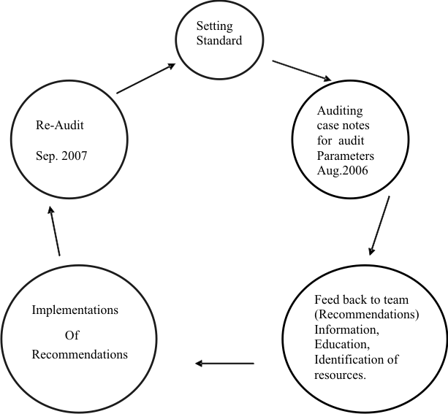

Fig. 1: Audit Cycle

# RESULTS OF THE AUDIT IN AUGUST 2006

Sixty-five patients on antipsychotic medications were identified, of which fifty-nine fulfilled the inclusion criteria. We randomly selected 42 patients for the initial audit in August 2006.

62% of these patients were between 30-50 years when the risk of metabolic syndrome is highest; 84% of the patients in the audit had been using the antipsy- chotic medication for more than 2 years; and the most commonly used antipsychotic in our patient group were Olanzapine and Clozapine. 45 % had a diagnosis of Schizophrenia; 15% had been diagnosed with Schizoaffective disorder and a similar number of pa- tients had a diagnosis of Bipolar disorder.

A note was made if the audit parameters were fulfilled within a month of the initiation of anti-psychotic medication. Weight was recorded in 43% of the patients; BMI and waist circumference had not been recorded at all. In. 24% of the patient’s personal history of diabetes was documented but none were asked about a family history of Diabetes. Blood glucose was recorded in 33% of patients. In 5% cases there was evidence to suggest that the General Practitioner had been requested to carry out the investigation but the results were not found in the notes. Lipid profile was recorded in 7% of the pa- tients and in 2% a request was made but results were not documented. Blood pressure was recorded in 38% of the patients.

# RECOMMENDATIONS MADE AT THE INITIAL AUDIT(AUGUST 2006)

As a result of the above mentioned findings fol- lowing recommendation were made to community men- tal health teams to improve the practice.

* To involve all the members of the CMHT (Community Mental Health Team) in moni- toring. A CPN (Community Psychiatric Nurse) volunteered to act as lead on this project.
* To raise awareness in supervision of all CMHT staff .
* To put monitoring form in all notes (Appendex 1)
* To re-audit in 6-12 months to see changes in practice.
* To keep monitoring as simple as possible hence BMI and waist circumference were omitted from monitoring form.

## Appendix 1

**Monitoring Form**

Name………..……… DOB ……... Medications……..……

Name of care coordinator …………………………

## Date/Initial Action

* Family history of diabetes Yes/No
* Personal history of diabetes Yes/No
* Blood Pressure——————mm Hg
* Weight ——————Kg
* Blood Glucose (attach copy )
* Lipid profile (attach copy)

This form should be completed at base line and every 6-12 months

# RE-AUDIT SEPTEMBER 2007

The purpose of the re-audit was to complete the audit loop and to check if the recommendations made in the earlier audit had been met. In addition, we wanted to identify any difficulties experienced and to suggest prac- tical changes to help implement them in a busy commu- nity team with limited resources. Seventy subjects were identified on antipsychotic medication, of whom 35 were randomly selected for reaudit. Results are shown in Fig 2.

**Comparison of the Two Audits**

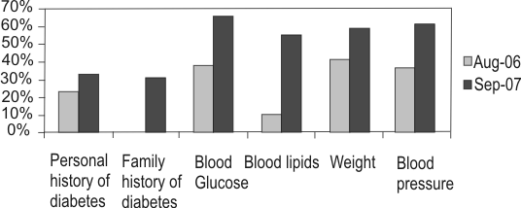

Fig. 2

# DISCUSSION

Recogition of patients who are at high risk of meta- bolic syndrome is an important step in improving and supporting the overall physical health of people with severe mental health problems.

A recent audit carried out on behalf of the UK Pre- scribing Observatory for Mental Health raised concerns about the obstacles to the screening process for the metabolic risk factors 5. They identified the main factors hindering the monitoring process to be as follows:

1. Uncertainty about whose responsibility the screening process is.
2. A lack of confidence about the interpretation of the results.
3. Limited access to the basic equipment.

Their audit revealed a recorded measurement within the previous year for blood pressure in 26% of patients, obesity in 26% of patients, blood glucose in 28%(or HbA1c)and plasma lipids in 22%. All parameters had been documented in only 11 % of the patients.

The results of this audit were not available at the time when we conducted our initial audit in August 2006; however our results are quite similar to it. Our audit revealed that blood pressure was recorded in 38% of the patients, weight in 42%, plasma lipids in 5%, blood glucose in 38% and personal history of diabetes in 22% of patients.

Our observations about the difficulties in carrying out this monitoring were also quite similar to the results

of above mentioned audit and questionnaire. The re- sults of our initial audit were presented and discussed in team meetings and the general consensus was that, as historically patients with severe mental illnesses had poor access to primary care services, it was important for mental health team to take a proactive approach in initiating, organizing and coordinating the physical health monitoring as well as educating the GPs alongside. We were mindful of the restrictions of our resources in terms of time and equipment and the im- portance of the involvement of primary care services to provide a holistic approach, but felt that we had to take a lead in helping them in identifying and managing the risks.

One of the nurses volunteered to act as a lead in this project and arranged seminars and talks for the team under the guidance of the consultant psychiatrist. She coordinated the efforts of the team and helped identify the access to equipment for monitoring. Those patients who remained reluctant to attend G.P surgeries for blood tests were offered tests at the CMHT base. The monitor- ing form was kept in red in the investigations section in the clinical notes to act as a prompt for health profes- sional seeing the patient.

Sharing of information with all team members and continuing education has helped us to overcome some of the constraints and we hope that continuing efforts of the lead nurse will keep the momentum going. These simple measures have resulted in a significant postive improvement in monitoring which was evident in the results of the re-audit carried out in September 2007. It has been suggested that the monitoring should be a part of the CPA (Care programme Approach) process to which all the patients in the UK receiving care from sec- ondary mental health services are subject.

A recent concensus statement recognises the time and budget constraints of the community teams but suggests that ideally patients on antipsychotic medica- tion should have a initial screening and an ongoing monitoring according to their needs5. Their recommen- dations are in some ways similar to what we suggest in our monitoring form .

The results of this audit are highly relevant to psy- chiatric practice in devloping country like Pakistan. The mental hrealth teams working in Pakistan may br grossly lacking in resources compared to those in UK . How- ever, it must be kept in mind that SouthAsain population

is already at high risk for metabolic syndrome. Incorpo- rating simple parameters such as those suggested in this audit can enhance the physical health of patients suffering from psychosis and these changes can be implemented with the help of a psychiatric nurse under the supervision of a consultant.

# ACKNOWLEDGEMENTS

We are very grateful to Kwan Tan community psychiatric nurse at Clarendon house who helped us with the project and took part in presentations and workshops.

# REFERENCES

1. A new worldwide definition of the metabolic syndrome. International Diabetes Federation, 2005.
2. Mukherjee S, Decina P, Bocola V, Saraceni F, Scapicchio PL. Diabetes mellitus in Scizophrenic patients. Comp Psych 1996; 37: 68 -73.
3. Allison DB, Fontaine KR, Heo M, Mentore JL, Chandler LP, Cappelleri JC, et al. The distribution of body mass index among individuals with and without schizophre- nia. J Clin Psychiatry. 1999; 60:215-20.
4. Brown S. Excess Mortality of Schizophrenia. A meta analysis. Br J Psychiatry 1997; 171:502-8.
5. Barnes TRE, Paton C, Cavanagh M, Hancock E, Taylor DM. A UK Audit of Screening for the Metabolic Side Effects of Antipsychotics in Community Patients. Schizophr Bull 2007; 33: 1397-1403.
6. Lawrie SM, McIntosh AM, Rao S. Critical Appraisal for Psychiatry. Edinburgh: Churchill Livingstone, 2001: p. 21.
7. Mitchell FGR, Fowkes MW. Audit reviewed: Does feed- back of performance change clinical behaviour? J R Coll Physicians 1985; 19:251-4.
8. Livingstone C, Rampres H. Atypical antipsychotic drugs and diabetes. Pract Diabetes Int 2003; 20:327-31.
9. Barrett E, Blonde L, Clement S, Davis J, Deblin J, Kane J, et al. Consensus development on antipsychotic drugs and obesity and diabetes . Diabetes Care 2004; 27: 596-601.
10. Barnett AH, Mackin P, Chaudhry I, Farooqi A, Gedsby R, Heald A, et al. Minimising metabolic and cardiovascu- lar risk in schizophrenia:Diabetes, obesity and dyslipidemia. J Psychopharmachology 2007; 21: 357-73.